* **Keurig K-Supreme SMART Coffee Maker**

Approximate Price: $100-$200

1. It can recognize the specific K-cup pod and customize brew settings

2. Its settings are created by the coffee experts for the most flavorful brew.

3. It supports five strength settings (Balanced to Intense), six temp settings (Warm to Max Hot), and four brew sizes (6, 8, 10, and 12 oz.) It can save up to 10 custom settings, such that the customers can enjoy their favorite cups.

**It does not leverage machine learning, so the settings are given by experts and saved by customers statically.**

4. Application for smart phones -- Keurig app:

a) To schedule brews remotely (supporting voice assist), customize brew settings, and create and save favorite settings.

b) To work with the smart Delivery to manage your supply. **We do not have this function.**

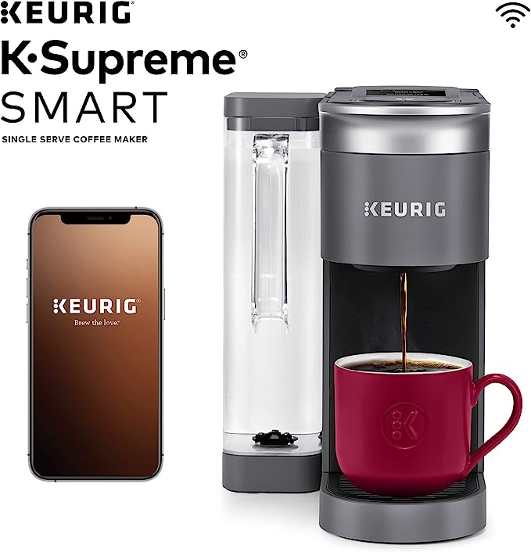 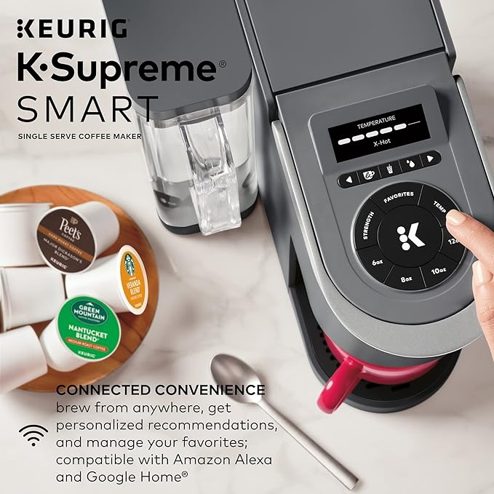

* SPINN Espresso & Coffee Machine

Approximate price: $799-$999

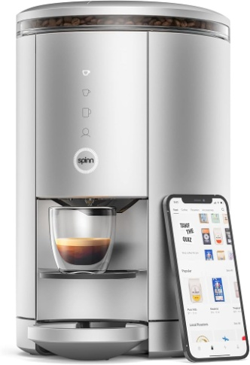 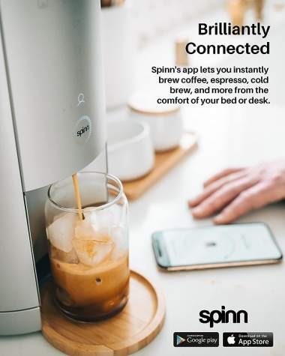

**Cafe X** is a startup that has developed fully automated robotic coffee bars that can prepare customized coffee drinks on demand without any human baristas. Their system uses industrial robotic arms, computer vision, and AI to precisely replicate the motions and techniques of expert baristas.

**Key Features**:

* **Robotic Baristas:** Cafe X's coffee bars use robotic arms with specialised attachments to grind coffee beans, steam milk, and prepare a variety of espresso-based drinks like lattes, cappuccinos, etc.
* **Customization:** Customers can customize their drinks through the Cafe X mobile app or in-store kiosks, specifying details like milk type, temperature, syrups, etc.
* **Computer Vision:** The system uses computer vision to identify the cup type and precisely position it for drink preparation.
* **Rapid Service**: With robotic efficiency, Cafe X claims their coffee bars can prepare drinks in under a minute once ordered.
* **Mobile Ordering:** Customers can place orders remotely through the mobile app and pick up their drink when notified it's ready.
* **Compact Design:** The fully automated coffee bars have a compact footprint suitable for spaces like office buildings, airports, malls etc.
* **Monitoring**: Operators can remotely monitor inventory levels, sales data, and machine functioning.
* **Self-Cleaning:** The machines are designed for automated self-cleaning and maintenance routines.
* **Locations**: Cafe X has strategically placed its robotic coffee bars in various high-traffic locations. These include airports, office buildings, and other busy areas where people crave a quick coffee fix. Some of the customer favorites include the Emerald Latte and Banana Cold Brew Coffee.

**Briggo:**

* **Robotic Barista Experience**:
  + Briggo’s Coffee Hauses are fully automated, robotic baristas available 24/7.
  + They cater to varying audience sizes and cycles without human intervention.
  + The small footprint (just 40 square feet) makes them ideal for compact spaces
  + Differentiator: Briggo’s commitment to quality, consistency, and convenience through robotics.
* **Customization and Quality**:
  + Briggo’s coffee kiosks allow users to tailor their coffee orders via a mobile app.
  + The machine contains 250 sensors that assess its performance, ensuring a perfect cup every time.

**Costa Coffee**

* **Intelligent Refreshment and Autonomous Coffee**:
  + It provides barista-quality coffee at the touch of a button—essentially an unmanned coffee shop in a compact box.
  + The hot and cold drinks are always crafted using freshly ground beans (Costa Coffee Signature Blend) and frothed fresh milk, all within the machine itself.
  + Exceptional Barista Quality: The Smart Café serves coffee with a premium design that cues freshness of ingredients.
  + Each cup is precision-made every time, fully mixed, and lidded for optimal taste.
  + End-to-End Touchless Preparation: The entire drink-making process is touchless, ensuring hygiene.
  + Simple Grab-&-Go Solution: Users can pre-order via a digital app and pick up their coffee seamlessly.
  + Availability: The Smart Café operates 24/7/365, without the need for human interaction, for up to 7 days.
  + Compact Footprint: It’s like a café without the build-out costs, fitting into tight spaces.
  + Live Data and Insights: The autonomous and intelligent platform continuously learns from customer behavior and preferences.
  + Real-time quality control ensures consistent excellence. The system adapts and improves over time.

**Thermador Built-in Fully Automatic Coffee Machines**

<https://www.thermador.com/us/products/coffee-machines>

* WiFi-enabled: Wi-Fi connection through the app enables remote start and the ability to program multiple orders for guests.
* Coffee customization: Customize up to 8 personalized beverages with NAMES from a single shot espresso, to hot water for tea, to extra large cappuccinos, so family members and guests can program their favorite drinks.
* LCD screen: Full color LCD display illustrates beverage selection, including size and temperature control.

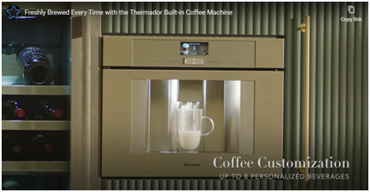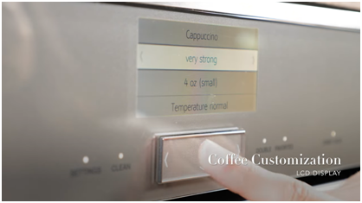

Here are also some other relevant beverage machines. I think they can also give some reference information about the market.

**Manitowoc Ice IYT0450A/SFA292 490 lb Half Cube Ice Machine w/ Ice & Water Dispenser**

<https://www.katom.com/399-IYT0450A161SFA29.html?utm_source=google&utm_medium=cpc&utm_campaign=%5BROI%5D%20Shopping%20-%20Commercial%20Ice%20Makers%20-%20General&utm_id=241933235&utm_content=19688627435&utm_term=&gad_source=1&gclid=Cj0KCQjwncWvBhD_ARIsAEb2HW_n0ig8fTIpyVGuQhA9v2tLTqlDkKVXmbckDsZZ6npCZiUGa4guP58aAiHREALw_wcB>

This is only an ice/water machine, and still costs $8,097.00. Its ice production can be adjustable based on the time of day or volume, but not automatically or intelligently.

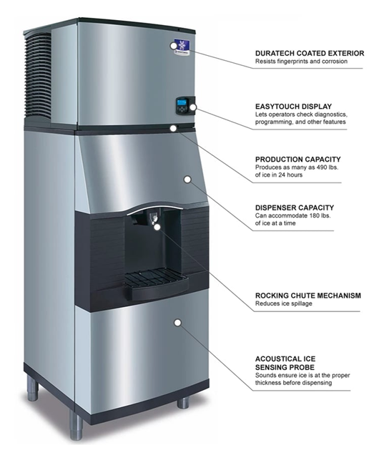

**Lancer Bevariety Dispenser**

<https://edco-distributing.myshopify.com/products/bevariety?gad_source=1&gclid=Cj0KCQjwncWvBhD_ARIsAEb2HW97bUcbLJ4uKz8J2E5UkTF-CZSVD0C-udbdAruu57DWN13_lDinpmEaAvNzEALw_wcB>

This is a typical beverage machine as we can see in many fast-food restaurants, and it costs $7,880.00. It provides 12 dispensable flavors to be selected by customers instead of AI.

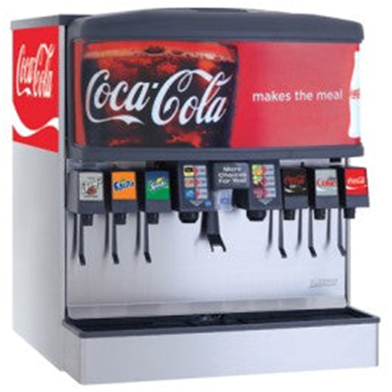

**Commercial Beverage Solutions and Hydration Stations by Prestwick Group**

<https://prestwick-companies.com/product-category/beverage-solutions/?utm_source=ga&utm_medium=sem&utm_campaign=beveragesolutions&gad_source=1&gclid=Cj0KCQjwncWvBhD_ARIsAEb2HW_KJsUO6AOCPk9TbbVGMjku91ZmsRLSEhhBRFwbxA6yb-WcQThB3FQaAik5EALw_wcB>

This product is suitable for golf courses, luxury hotels, and premium resorts. The cooler boxes and ice boxes are the epitome of functionality and convenience for players and guests. In special, the producer emphasizes its product's value in the advertisement:

* it can be customized to extend brand awareness, convey important messages or create partnership opportunities;
* It can help quench the customers’ thirst in a way that reflects the brand’s identity and commitment to excellence.

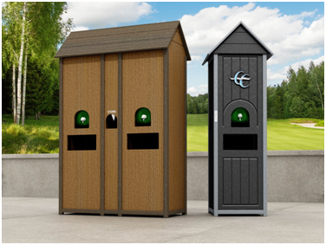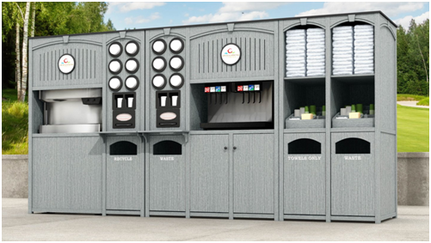

Our product Advantages:

* **Widespread Availability**: Deploying machines at gas stations, convenience stores, and office break rooms provides much wider accessibility compared to competitor's limited standalone locations.
* True Mobility: With app-based ordering system, customers can order coffee from your machines anywhere, not just at the fixed coffee bar locations like competitors.
* Timing Flexibility: App's ability to schedule coffee orders in advance and receive notifications allows customers to get freshly brewed coffee at their preferred time.
* Personal Touch: Printing names/messages on cups adds a personalized experience lacking in competitor's fully automated system.
* Cost-Effective: Leasing model could make our machines more affordable for businesses compared to investing in competitor's robotic coffee bars.
* Machine Learning for Preferences: Leverage user reviews and order data to build machine learning models that can predict and suggest personalized drink recommendations.
* Subscription Plans: Offer subscription-based plans for frequent customers to get discounts and rewards.
* Voice Ordering: Integrate voice assistants like Alexa or Google Assistant for hands-free ordering through voice commands.
* Loyalty Program: Implement a loyalty program where customers earn points for purchases and can redeem rewards or free drinks.
* Inventory Management: Develop an intelligent inventory management system that can alert when supplies are running low and automate re-ordering.
* Environmentally Friendly: Emphasize eco-friendly practices like using biodegradable cups, reducing waste, and optimizing energy efficiency.
* Link fingerprints to personalized coffee profiles. Combine fingerprint scanning with voice commands for a seamless experience.
* Customers can adjust the temperature of the coffee they receive.
* Seasonal Specials and Limited-Edition Blends: Introduce seasonal coffee blends or collaborate with local roasters for limited edition flavors. Notify users when these special blends are available. Create excitement around trying new and unique coffees.
* Social Sharing and Rewards: Encourage users to share their coffee experiences on social media. Offer rewards (discounts, free drinks) for sharing photos or writing reviews. Build a community of coffee enthusiasts who promote your brand.
* Health-Conscious Options: Offer sugar-free, dairy-free, and low-calorie alternatives. Display nutritional information for each drink.

Costa Coffee Smart Café (Autonomous System): The price for the Costa Coffee Smart Café autonomous system is $285,000. Cafe X (Robotic Coffee Bars): The cost of a Cafe X robotic coffee bar system is $285,000, with an annual software and services fee of $15,000